People think that electricity gives light. However, this is wrong. In modern lighting systems such as an LED which has a chemical inside. Once you provide the chemical with additional electrons it becomes hot. The heat creates the light.

DC is better for heating than AC.

Trains run on DC.

DC there is only resistance in ohms (RΩ )
Voltage drops happens because of the distance.

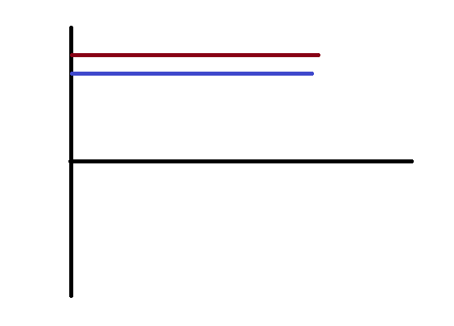

In phase, DC when you put pressure behind it flows.

An example, of DC is solar panel and battery.

In order to create electricity you must spin a magnet inside a magnet.

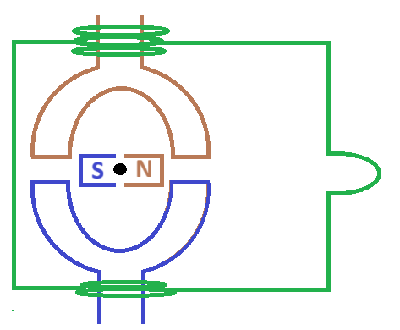

Electrons only flow in a complete circuit.
Because, electrons need to take the place of other moving electrons.
Electricity is about capturing magnetism.

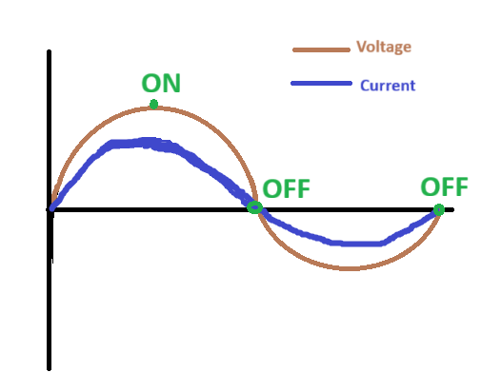

In the OFF state the magnet is completely flat. No electrical current is being induced.

Frequence is measured in Hertz.
Power = Current x Voltage. Measured in watts.

In phase/in sync current and voltage are in a purely-resistive load.

The voltage of the sockets is 230 volts.

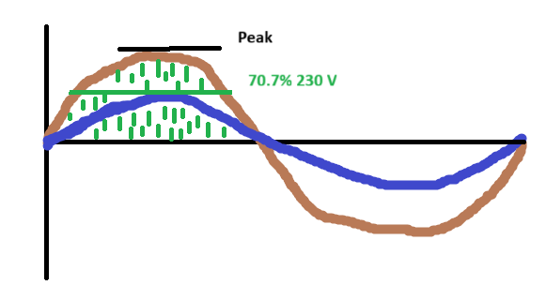

RMS => Root Mean Square

RMS is 0.707 which means 70%.

The Voltage is only at the peak for a very short time. So they wanted to find the DC equivalent which is 230 volts. This is the 70.7%.

Coil same as an inductor. Because, it induces a magnetic field.

When you put electricity through a coil it induces a magnetic field. When the magnetic changes position the magnetic field collapses and starts up again. Which is why the graph of an AC is in a wave like motion.

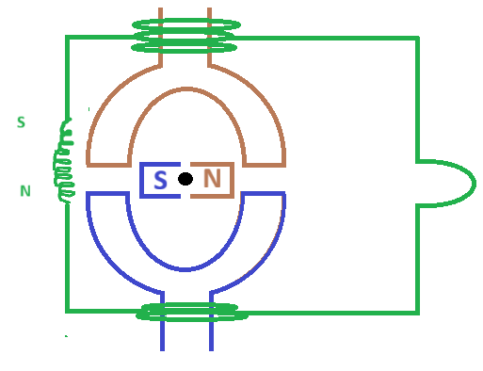

In an inductor you apply pressure (voltage) then there is movement (current).
Current lags voltage in an inductor by 90 degrees. Because, there is a moment where there is a plain state. Which causes the electrons to collapse.

The Breakdown of the resistances

XLΩ - Inductive reactance is measured in ohms Ω. This is a resistance in a coil ( the inductor).

RΩ - We have resistance from the copper wire itself and the distance.

Z = total resistance which is XLΩ + RΩ .

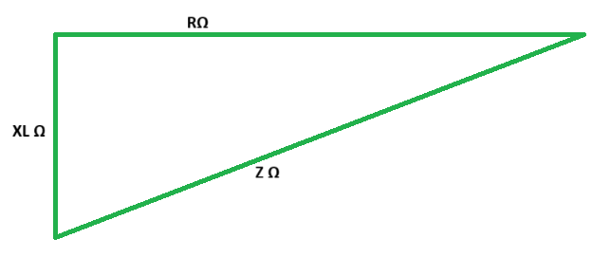

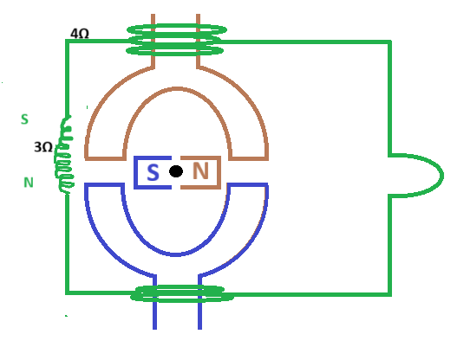

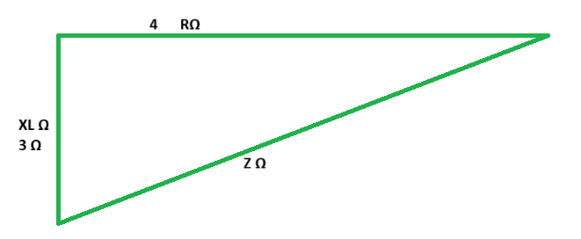

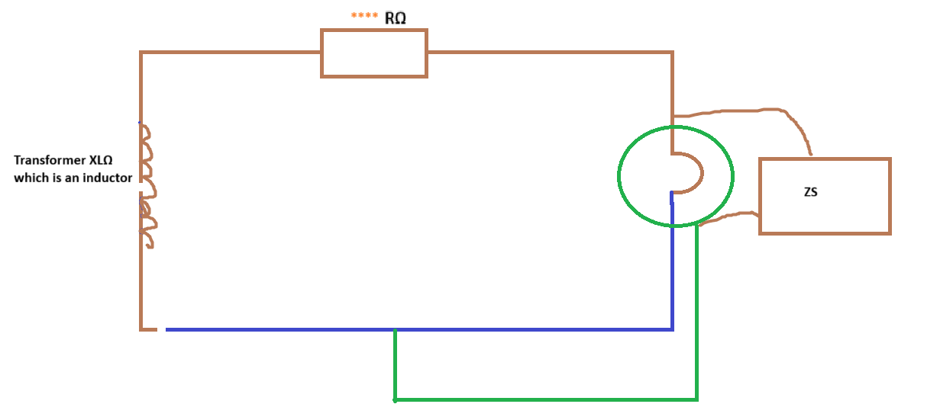

Ze = X + R.

Zs = Ze + (R1 + R2).

Ze is from the transformer to ****

